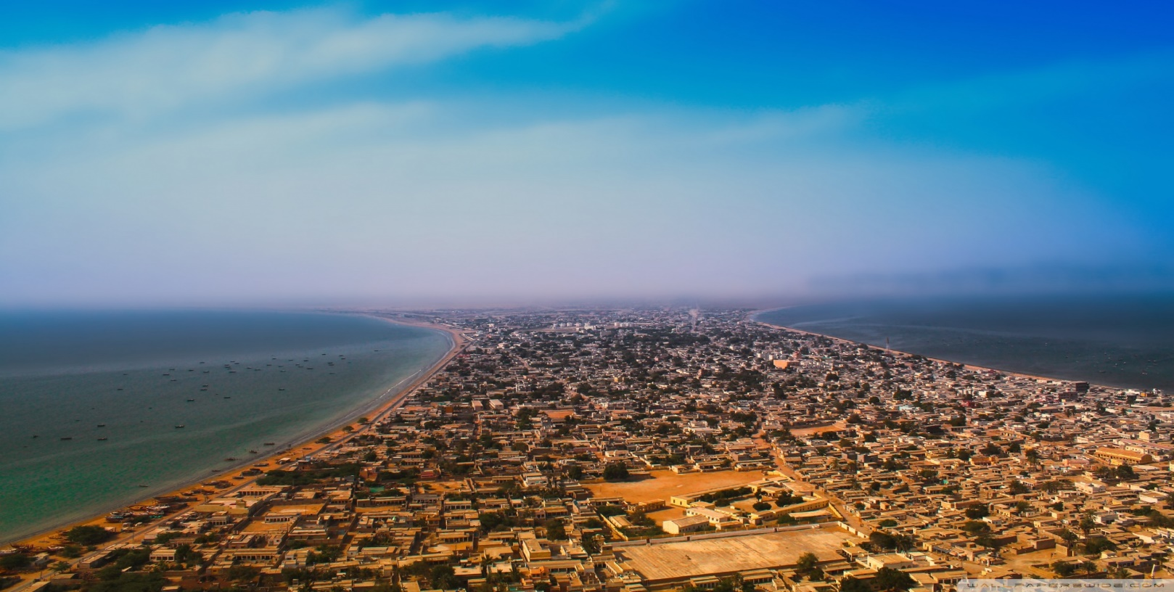

**GAWADAR BEACH**

**Gateway to the Arabian Sea: Gwadar Beach**

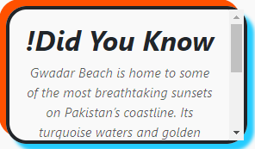Gwadar Beach, located in the coastal city of Gwadar in Balochistan, serves as a stunning gateway to the Arabian Sea. This picturesque beach boasts expansive golden sands and crystal-clear waters, creating a serene escape for nature lovers and travelers alike. The mesmerizing beauty of Gwadar Beach is enhanced by the backdrop of rugged cliffs and hills, making it a dream destination for photographers and adventurers. Its tranquil environment provides a perfect retreat for those looking to disconnect from urban life and soak in the soothing sounds of the waves. Gwadar Beach is not just a scenic spot but a testament to the raw and untouched beauty of Pakistan’s coastline.

**The Untamed Beauty of Gwadar Beach**

Gwadar Beach stands as a testament to the raw,

untamed beauty of nature. The beach offers a unique

blend of dramatic landscapes, with vast stretches of sandy

shores merging into the deep blue waters of the Arabian Sea. Surrounding this coastal paradise are striking natural formations, such as the Hammerhead and the Sphinx of Gwadar, which add to its allure. Visitors can witness the vibrant marine life and enjoy activities like fishing, boating, and dolphin watching. Gwadar Beach captures the essence of coastal Balochistan, offering an authentic experience for adventurers and peace seekers alike.

**A Rising Star on Pakistan’s Tourism Map**

Gwadar Beach is gaining recognition as a rising star in Pakistan’s tourism industry. With the development of the Gwadar Port and the region’s increasing accessibility, this coastal gem is becoming a favorite destination for travelers from around the country and beyond. The beach’s untouched beauty, combined with its growing facilities and infrastructure, makes it a promising spot for eco-tourism and sustainable travel. Whether you're looking to explore the local fishing culture, indulge in a seafood feast, or simply relax on the sandy shores, Gwadar Beach offers a unique and unforgettable experience.

**Discover Gwadar Beach: Where Nature and Culture Meet**

Gwadar Beach is more than just a scenic retreat—it is a place where nature and culture come together. The beach is an integral part of the lives of the local fishing communities, offering visitors a glimpse into their rich traditions and heritage. From enjoying freshly caught seafood prepared by the locals to learning about the history of the Gwadar region, there’s much to discover here. The beach also provides a stunning location for cultural events, including festivals and traditional Balochi music performances. Gwadar Beach is not just a destination but a journey into the heart of Balochistan’s natural and cultural wonders.

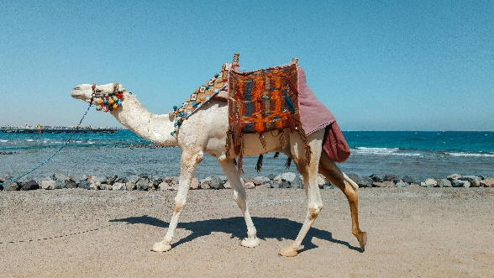***RIDING***

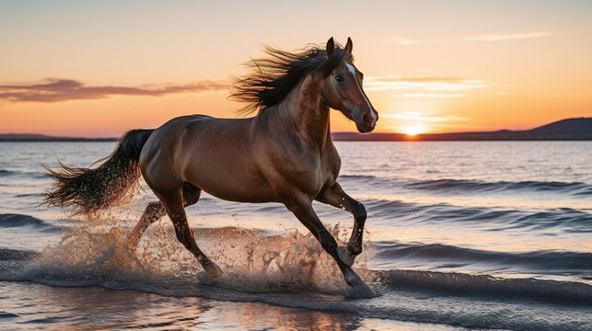

***! Camel riding at GWADAR BEACH is a fun and iconic activity for visitors. Decorated camels offer safe rides guided by skilled handlers.***

***! Horse riding at GWADAR BEACH is another thrilling activity for visitors. Beautifully adorned horses are available for guided rides along the shoreline***

***! Horse riding at GWADAR BEACH is another thrilling activity for visitors. Beautifully adorned horses are available for guided rides along the shoreline.***

**Experience the Unmatched Beauty of Gwadar Beach**

Gwadar Beach, nestled on the southern coast of Pakistan, is one of the most pristine and untouched coastal destinations in the region. With its unspoiled sandy shores, crystal-clear waters, and majestic views of the Arabian Sea, the beach presents a perfect blend of natural beauty and serenity. The golden stretch of sand and the gentle lapping of waves create a peaceful ambiance, making it an ideal spot for relaxation and rejuvenation. Visitors can enjoy leisurely walks along the shore, meditate to the sound of the ocean, or simply relax in the warm sun while watching a spectacular sunset. What makes Gwadar Beach stand out is its tranquility and seclusion, offering an escape from the hustle and bustle of everyday life. It is a sanctuary for those looking to reconnect with nature and experience an authentic, peaceful atmosphere far from crowded tourist spots.

**An Adventure Seekers’ Paradise at Gwadar Beach**

While Gwadar Beach is a perfect retreat for those seeking calm and tranquility, it also offers a wide range of exciting activities for adventure lovers. The crystal-clear waters of the Arabian Sea invite tourists to engage in various water sports, from thrilling jet skiing to peaceful kayaking. The beach is a great spot for fishing enthusiasts, with opportunities to catch a variety of local fish. The surrounding rugged terrain and cliffs are perfect for those who enjoy hiking and exploring new landscapes, with breathtaking views waiting at every turn. Additionally, the area around Gwadar is rich in wildlife, making it an excellent destination for birdwatching and nature photography. Whether you're looking to indulge in exciting water activities or explore the natural beauty of the coastline, Gwadar Beach provides an unforgettable experience for adventurers and nature lovers alike. The fusion of peaceful retreats and action-packed activities makes it a truly unique destination that caters to all types of travelers.

**LOCATION**

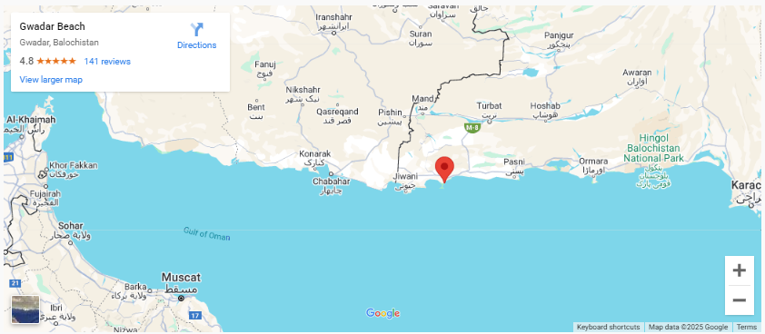

Gwadar Beach is located in Gwadar, a coastal city in Balochistan, Pakistan, along the Arabian Sea. It’s known for its scenic views and calm waters.

**Why Visit Gwadar Beach?**

**Gwadar Beach is a perfect blend of tranquility and adventure, offering visitors a serene escape with its golden sands and clear azure waters. It’s an ideal spot to relax, enjoy breathtaking sunsets, or explore the beauty of the Arabian Sea through swimming and fishing. For thrill-seekers, the beach also offers exciting water sports and hiking opportunities. Whether you’re looking to unwind or seek adventure, Gwadar Beach caters to all types of travelers.**

**FEATURED PRODUCT**









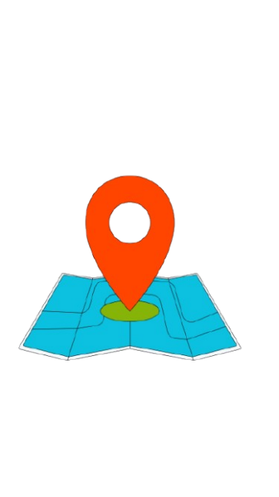**SHOP LOCATION**

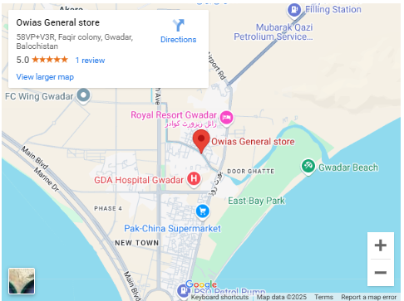

Owais General Store is located in Quetta, the capital city of Balochistan, Pakistan. It's a local store known for selling general items and daily essentials.